**FORM – 2**

**THE PATENTS ACT, 1970**

(39 of 1970)

&

THE PATENTS RULES, 2003

**COMPLETE**

**SPECIFICATION**

# (See Section 10 and Rule13)

Idea Incubation in Individual and Community Virtual Minds

**DIPESH RAMDAS WALTE**

Independent Researcher

Akurdi, Pune 411033

**GANESH DESHMUKH**

PCCOE, Pune

Akurdi, Pune 411033

**An Indian national**

**The following specification particularly describes the invention and the manner in which it is to be performed.**

Idea Incubation in community virtual minds.

**FIELD:**

**[0001]** In the rapidly evolving digital age, the conceptualization and incubation of ideas and startups require innovative approaches to harness the vast potential of user-generated data. We propose a groundbreaking social network platform that leverages an extensive array of user data, including browsing behaviour, psychometrics, social media activity, and professional profiles and their connections with one another to create a detailed virtual representation of an individual's cognitive and emotional landscape.

**BACKGROUND:**

**[0002]** The journey from concept to market viability is fraught with uncertainties and is often a time-consuming and resource-intensive process. Our platform provides an environment where ideas can be incubated, tested, and validated at an unprecedented pace, leveraging virtual simulations to predict real-world outcomes. This not only reduces the time and cost associated with developing new products and services but also increases the likelihood of success in competitive markets.

**[0003]** The platform's innovative use of data allows for a more nuanced understanding of user needs, preferences, and behaviours, enabling the rapid development of products, services, and marketing strategies. We do this by user profiling and matching the user skills and passion with the idea another user wants to incubate.

**[0004]** Furthermore, the social network aspect facilitates the formation of virtual communities, fostering collaboration and knowledge exchange among like-minded individuals and virtual minds with complementary skills and interests.

**BRIEF DESCRIPTION OF ACCOMPANYING DRAWINGS**

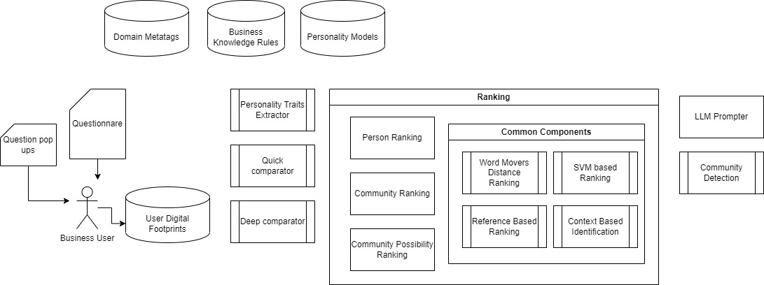

The architecture consists of various modules:

1. Domain Meta tags

Domain meta-tags include meta-tags which represent the skills or qualities of a person. It is a Decision Tree like structure which have different skills as it nodes and emerging subtrees include the subskills.

For eg ->

The domain meta-tags for a software developer would be

1. Good problem solving skills
2. Good development skills (Frontend, Backend,Devops)
3. Good Computer Fundamentals knowledge

2. Business Knowledge Rules

Business knowledge defines the skills or requirements of a business or a project. A idea/project/business may require specific skills or mindset of a person. Business Knowledge Rules will include the data of such metatags.

3. Personality Models

Include the personality model of a person currently we only using 16 pf personality model.

4 .Personality Traits:

Extract the personality traits for each person from linkden dataset. It will include the skills of each person, their domain expertise, experience and interests in different domains.

5. Deep Comparator

A comparator model which will compare individual datapoint based on details comparison with each and every member of the dataset. It is more accurate but has more time complexity

6. Quick Comparator

A comparator which will compare or cluster individual datapoints into different groups and compare them based on their groups instead of individual comparison. It is less accurate but provide fast results.

7. Ranking:

Ranking will be used to rank the results based on the given search query, for example there would be:

1. Person ranking: Here people would be ranked based on the similarity of the skillset.
2. Community ranking: Community represents a group of people with diverse skills required for a particular job. So, here various communities will be ranked on the basis of desired skills as per requirement.
3. Community Possibility ranking: Here, the people within a community would be grouped on the basis of similarity of the skills in a permutation manner and then followed by ranking as per the needed skills.

This ranking is done using various components or algorithms such as:

1. Word Mover’s Distance :

WMD can be used to compute the similarity between a query document and a set of candidate documents. The documents can be ranked based on their WMD scores, with lower scores indicating higher similarity to the query.

1. RankSVM :

RankSVM is used for ranking when you have a bunch of things (like search results or products) and you want to figure out the best order for them. It learns from examples where you know the correct ranking. For instance, if you're ranking movies, and you know that "Star Wars" should be ranked higher than "The Emoji Movie," RankSVM learns from these examples.

It looks at pairs of things and learns which one should be ranked higher. Then, when you have a new set of things, it predicts their ranking based on what it learned. So, it helps systems like search engines or recommendation systems show you the most relevant or preferred items first.

8. LLM Prompter

LLM (Large Language Model) is essential for such a project as LLMs can acquire knowledge about syntax, semantics and ontology inherent in human language corpora. Our choice of LLM is GPT-3, where we will feed the query to GPT-3 using an API key. This will help us extract Semantic Understanding, Relationships between Entities, Key Concepts and Topics and Contextual Information of the query.

9. Community Detection

We claim that:

1. Facilitating idea incubation in an annotated social network through talent recognition by user data analysis, user profiling and psychometrics.

**DIPESH RAMDAS WALTE**

Visual Domain Concept Mapping and Content Consumption API

**ABSTRACT**

**Identifying and accessing the right talent is a significant challenge for startups and established businesses alike. By creating a virtual ecosystem of minds with diverse skills and expertise, Virtual Mind enables entities to connect with and leverage this virtual talent pool, addressing gaps and driving forward their initiatives more efficiently.**

**The siloed nature of traditional social networks and professional platforms limits the scope for interdisciplinary collaboration and knowledge exchange. Virtual Mind transcends these boundaries, fostering a community of virtual minds that can work together, combine skills, and share insights, thereby enhancing the quality and impact of the innovation process.**

**A user generates a lot of data by consciously creating content or by consuming content. By aggregating these diverse data points into a coherent "virtual mind," the platform offers a unique ecosystem where ideas and startups can be incubated, developed, and refined in a simulated environment that mirrors real-world interactions and market dynamics. This is done by matching various attributes in the idea description using natural language processing with the most ideal suited candidates or a connected community.**

**As we venture further into the digital era, our platform could play a pivotal role in shaping the future of entrepreneurship, innovation, and social interaction.**